Group Pension Plan messages for your suitability reports

To help you compile your clients’ suitability reports detailing why you’re recommending Royal London as the preferred pension scheme provider, we’ve included some key messages about our workplace pension that you may want to use.
It’s important that your suitability reports are tailored towards your client’s individual needs. If you would like to find out more about what else you need to include within your reports, our Workplace pension suitability report template may help you.
You should ensure that your own final version satisfies the requirements of your regulatory body.

Why Royal London?
- Royal London’s Group Personal Pension is designed to suit the needs of both you and your employees.
- Royal London’s a different kind of financial services company because unlike its main competitors, it’s a mutual. This means it’s customer owned, by people like your employees, rather than shareholders.
- It’s committed to helping build financial resilience while also acting and investing responsibly. It does this through engaging with the companies it invests in, on your employees’ behalf, to influence positive change and integrating environmental, social and governance (ESG) factors into its Governed Range solutions, including the default investment option.
- As the UK’s largest mutual life, pensions and investment company, it can offer solid financial foundations. As at 31 December 2023, its total group assets under management was £162 billion.

Share in Royal London’s success
- Royal London believes its customers should share in its success. When you choose a workplace pension with Royal London, your employees automatically become members of Royal London when they join your pension scheme.
- Royal London uses some of its profits to help provide you and your employees with better products and services.
- It also believes its members should share in its success. And it really wants its members to feel the benefit of being part of Royal London.

When it does well, it aims to boost members’ pension savings by adding a share of its profits to their plans each year. It calls this ProfitShare.

There’s no guarantee Royal London will be able to award ProfitShare every year so this shouldn’t be relied upon.

Service and accolades
Royal London understands the importance of providing a first-class service.

- Once you've decided to move your pension scheme, it’ll make sure it’s a smooth transition for both you and your employees, and that your scheme is set up for success from day one.
- Royal London received 5 stars for service three years in a row at the Corporate Adviser awards – the only group pension provider to receive this rating.
- Royal London has been awarded the maximum five stars for service fifteen years in a row at the Financial Adviser Service Awards - a reflection of its commitment to outstanding service.
- Royal London recognises that many employers value quality employee communications, as this helps engage employees in their pension scheme. So it makes sure that communications are both clear and simple to help your employees see the value of your ongoing investment in them.
- The fact that Royal London’s service and performance have been acknowledged across many award categories is testament to the expertise of its people and unwavering commitment to doing all it can for employers and their employees.
Royal London awards
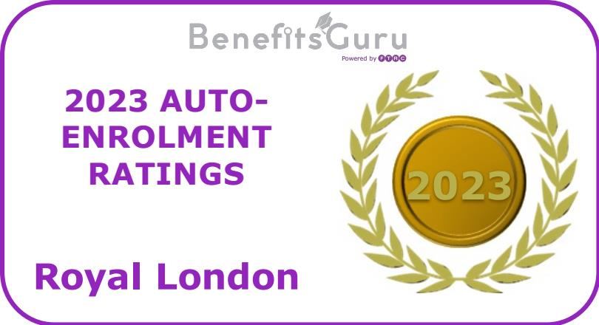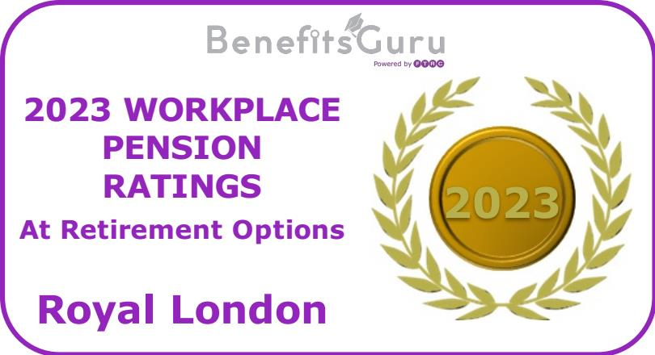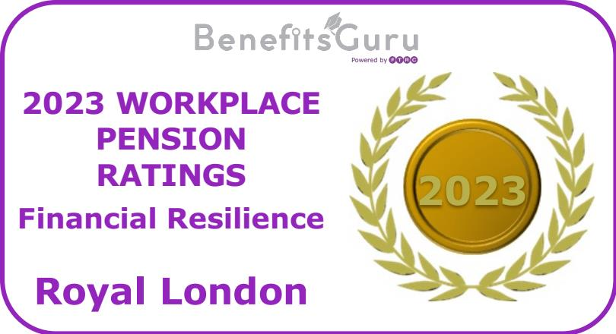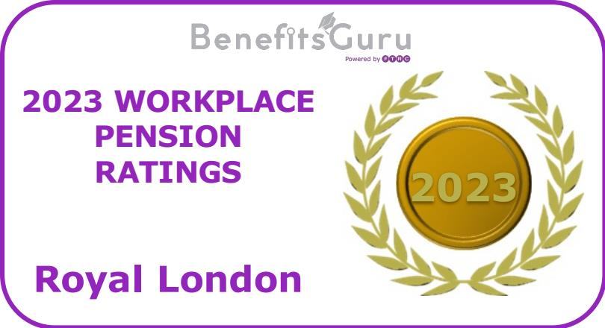

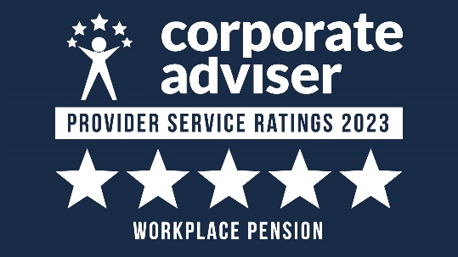

Employee engagement
- Royal London believes in meaningful, regular conversations with your employees to help engage them in their pension savings. To help with this, it provides first-class communications at the points when they matter most.
- It will provide you with a range of employee engagement materials to raise awareness about the change of pension provider, including digital and printed posters, factsheets and email templates to share with your employees.
- Once the scheme is set up, it will issue an enrolment pack to help your employees decide whether to stay in the plan. The pack summarises the key benefits of the plan and shows the potential pension savings employees could build up.
- Royal London will encourage your employees to download its free mobile app, so that they can keep in touch with their pension regularly. Using the app, your employees can:
  - See what’s been paid into their plan so far
  - See where their pension savings are invested, how their investments are performing
and what their pension might be worth in the future
  - See, and be notified of, any ProfitShare awards
  - Make single contributions and transfer other pension savings
  - View and add beneficiaries
  - Access a range of financial wellbeing content
- All this is supported by an employee hub which your employees have access to from the moment they join your scheme. From there, they'll be able to see the tools, information, financial wellbeing content and educational materials they need to help them keep track of their pension savings.

Employer engagement
Royal London will keep you up to date with what's happening with your scheme along the way.
Sharing expertise
- Royal London will share its pensions experience with you in its regular newsletter - Pension Matters. It’s designed to update you on all things pensions related that could affect you and your employees – like new government legislation, or if it’s awarded ProfitShare to members.
- Its dedicated employer website has all the information you need to fulfil your employer duties and encourage your employees to engage with their pension.
Help with your scheme governance
- Royal London will make sure you’re up to speed and know exactly what’s happening with your pension scheme, at all times. And I’ll work with Royal London to provide an up-to-date governance report as and when you need it.
Communicating your ongoing duties
- Royal London’s online service is set up to help you meet and complete your ongoing duties. From welcome packs to reminder letters, it has all your statutory communications covered.
- Every three years you must automatically re-enrol any eligible employees who have opted out of your scheme. This is called cyclical re-enrolment. Royal London produces all the necessary communications to make the process simple for you and your employees.
Helping to engage your employees
- Royal London’s employee engagement toolkit has communications materials that you can use to support regular communications with your employees. You can use this material to encourage your employees to make the most of their workplace pension, improve their financial education and build their financial resilience.
- Its free financial wellbeing service provides access to ongoing financial education and guidance, helping employees improve their financial knowledge, confidence and wellbeing.

Investment
Most of your employees are likely to remain in the scheme’s default investment option. So it’s important to have a high-quality default option in place.
Royal London offers a number of investment solutions, depending on your employees’ needs.
- Its default investment has been designed with Department for Work and Pensions (DWP) guidelines in mind so you can feel confident you’re giving your employees an investment option that’s in line with those.
- Its default investment option is the Balanced Lifestyle Strategy (Drawdown). This invests in three of their risk-targeted Governed Portfolios within Royal London’s Governed Range.
- Its Governed Range provides lots of investment choice, including:
  - Governed Portfolios – your employees can choose a portfolio that takes account of their attitude to risk and how long they have until retirement.
  - Lifestyle strategies are designed for employees who have a specific retirement goal in mind – like taking their money as cash sums, buying an annuity or enjoying a regular income from their pension savings (drawdown).
- The investment options within the Governed Range take into account various responsible investment considerations. They also benefit from active management and impartial governance - at no extra cost.
- The Governed Range is looked after by Royal London’s Investment Advisory Committee (IAC). The independently led IAC oversees the design of the Governed Range and reviews it on an ongoing basis to make sure each portfolio continues to meet its objective.
- If any of your employees prefer to make their own investment decisions beyond the Governed Range, there’s also a full fund range with more than 180 individual funds. This includes sustainable fund options for employees who want to align their investments with their values. While these funds don’t benefit from the same level of oversight as the ready-made options in the Governed Range, each of them is individually selected from leading investment houses, and they’re all closely monitored to make sure they continue to perform in line with their objectives.
- Royal London’s approach to responsibly investing your employees’ money focuses on four key areas. It believes this approach enables them to actively influence the transition to a more sustainable world and help deliver better outcomes for your employees, as well as wider society. These are:
  - Stewardship and voting
  - Environmental, social and governance (ESG) integration
  - Advocacy and engagement
  - Active management

A range of retirement options
Royal London has a range of retirement options to suit individual employee needs. Employees can access their pension savings any time after age 55. This will increase to age 57 from 6 April 2028. Employees can choose to:
- Leave their pension savings invested until the time is right for them to take them.
- Take one or more cash payments. This can be some or all of their pension savings.
- Secure a regular guaranteed income by buying an annuity.
- Get flexible access to their savings with Income Release, Royal London’s income drawdown option.
Income Release
If your employees want to enjoy flexible access to their pension savings, they can move some or all of their money into a new plan with the Income Release facility.
Rated 5 star by Defaqto, Income Release offers a comprehensive range of features and benefits. For example, a range of tax-free cash and income options.
- Flexible saving – they can continue to save into their workplace pension as long as they leave a minimum of £200.

- Lowest charge – if the annual management charge for regular contributions is lower on their group plan, they’ll keep this when they move over to their new plan.

- Value for money – there’s no charge to start using Income Release.

- Low starting amount – they only need to move £10,000 into their new plan to start using Income Release.

- Leave money for loved ones - employees can choose to leave their pension savings to their loved ones in a tax-efficient way when they die.

Supporting non-advised employees
If you’re unable to offer your employees access to financial advice, Royal London will support them when it comes to retirement by providing guidance to help them understand their options.
Dedicated retirement team – Royal London’s at-retirement team is on hand to talk your employees through their retirement packs and what their options are. If your employees decide they want to start taking money from their plan, and move into drawdown using the Income Release facility, its retirement team will then walk them through their choices and discuss what’s involved, including any risks.
Drawdown governance service - Once in drawdown, Royal London’s drawdown governance service will check the level of income they’re taking to help them maintain a sustainable level of income. If it looks like they could run out of money earlier than planned, Royal London will contact them to let them know and give them options to get back on track. Royal London doesn’t charge your employees to do this, and it will always refer them to a financial adviser if they need professional financial advice.
Annuity bureau - For employees who feel an annuity is the right retirement option for them, Royal London has its annuity bureau, who’ll take them through the process and help identify the right annuity for them.
Guidance team – If your employees need additional support, perhaps with things like understanding their options or looking for help after a life shock, Royal London’s guidance team will be on hand to support.
Royal London’s financial wellbeing service provides education and guidance to help customers achieve a good standard of living today and in retirement.

Investment pathways
If any of your employees decide they want to access their savings in a flexible way, Royal London offers four investment pathway options. The pathways were introduced by the Financial Conduct Authority (FCA) to improve the retirement outcomes for customers.
Each pathway has been designed to meet specific retirement goals. Depending on your employees’ individual needs, they can choose from:
- I have no plans to touch my money in the next 5 years
- I plan to use my money to set up a guaranteed income (annuity) within the next 5 years
- I plan to start taking my money as a long-term income within the next 5 years
- I plan to take out all my money within the next 5 years
They’ll then be offered an investment pathway solution.

March 2024 CAT CODE O GPPP O 0001/4

